CO2 Foodprint: Carbon Footprint Calculator

Members: Soma Badri (product owner), Riley Murphy (scrum master), Destin Wong, Raymond Lee, Kelley Broderick

Sprint Date: Weeks 6-8

Revision Number: 2

Revision Date: May 10, 2021

TA: yogolan@ucsc.edu

**Scale for Story Points**

1: X small

2: Small

3: Medium

5: Large

8: X Large

13: XXL

20/21: Huge

Sprint 3

|  |  |  |
| --- | --- | --- |
| Goal | Story Points | Priority |
| As a user, I want to have a profile so I can see my information   * Set up backend to take in google auth code and be able to save a json object for each user with recipes and such (2 hrs) | 20 | 1 |
| As a user, I want to see ideas/tips/swaps so that I can take inspiration from them in my own recipes   * Set up backend for seeing other peoples posts/profiles in dashboard (3 hrs) | 13 | 2 |
| As a user, I want the ability to post recipes so that I can share my personal recipes/tips/swaps   * Post recipes page UI (2 hrs) | 13 | 3 |
| As a user, I want the ability to see my friend’s profiles so that I can have a social aspect   * Set up backend for seeing friends (get call) (2 hrs) | 20 | 4 |

|  |  |
| --- | --- |
| Backlog from Sprint 2 | Story Points |
| As a user, I want the ability to have a score for emission use so I can strive for a more sustainable lifestyle and measure it numerically   * Save your recipe score to an overall user emission count (2 hrs) | 13 |
| As a user, I want the ability to input emission alternatives (such as riding bike instead of a car) so that I can track my emission use in/out   * Same idea as food but with minusing (2 hrs) | 8 |

Total ~13 hrs

Initial Task assignment:

Riley: see friends ideas/tips/swaps

Destin: calc transport page

Soma: post page

Raymond: navbar

Kelley: calc transport page, get call for friends profile

Burnup Chart:

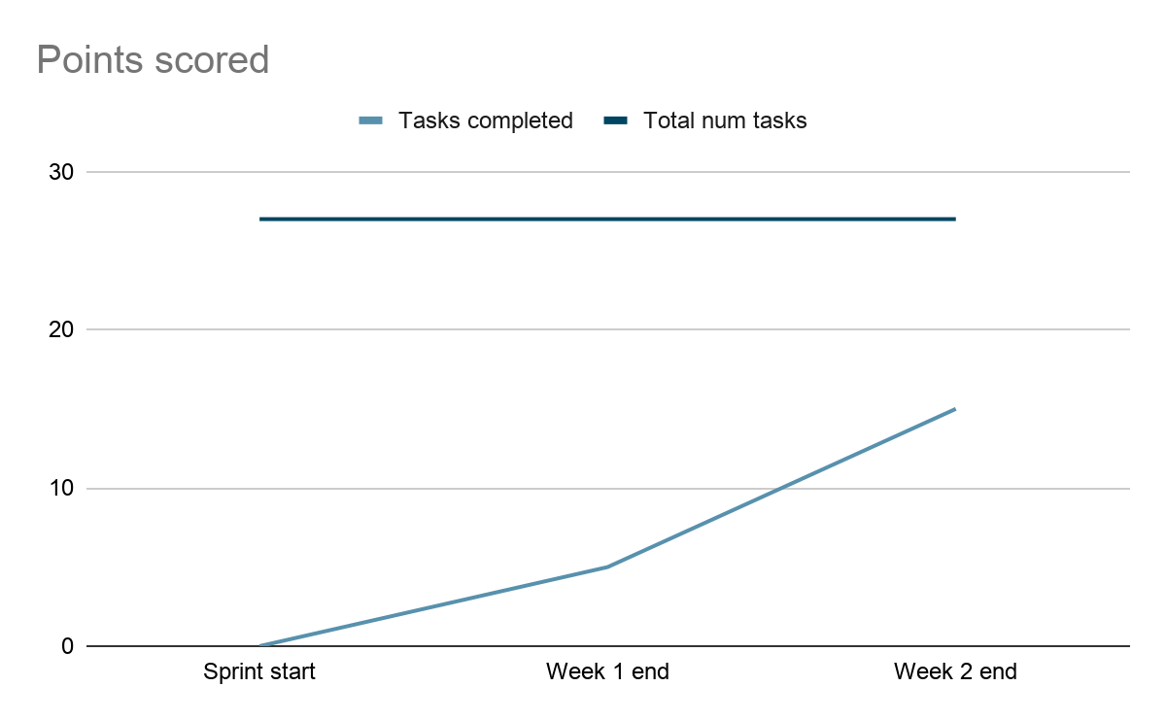

|  |  |  |  |
| --- | --- | --- | --- |
| Tasks | Not started | In progress | Complete |
| Implement minus pts for good transportation |  |  | x |
| Set up backend to take in google auth code and be able to save a json object for each user with recipes and such |  |  | x |
| Set up backend for seeing other people’s posts and  profiles (get call) | x |  |  |
| Post recipes page UI |  |  | x |
|  |  |  |  |

Scrum board:

Sundays 1pm

Tuesdays 3-4 (with TA)

Thursdays 10:30am